**Database-Assignment-3**

1. Create a stored procedure named GetProjectAssignments that retrieves all assignments for a specific project, including employee details and role.

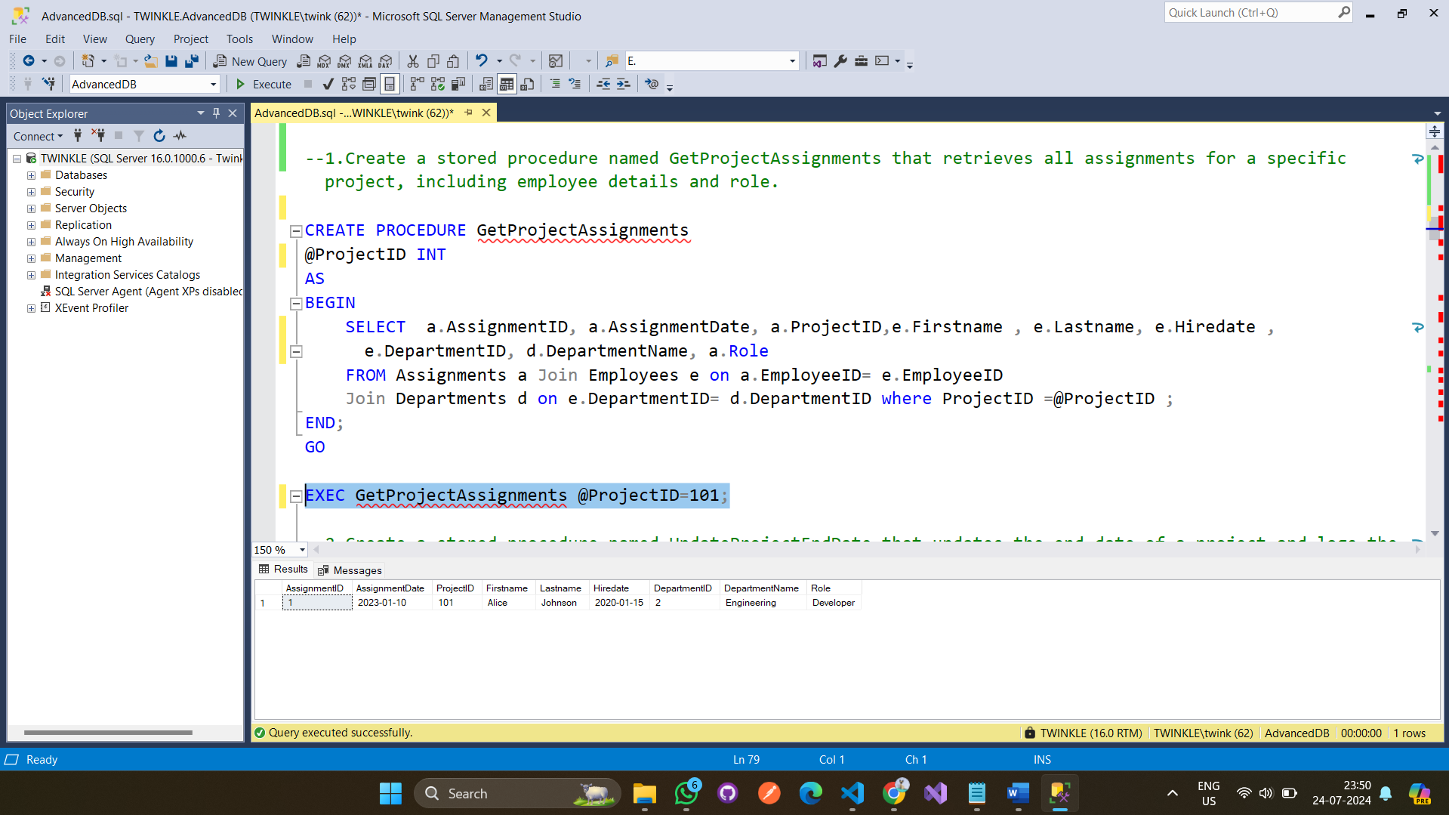

1. Create a stored procedure named UpdateProjectEndDate that updates the end date of a project and logs the change in a new table ProjectLog.

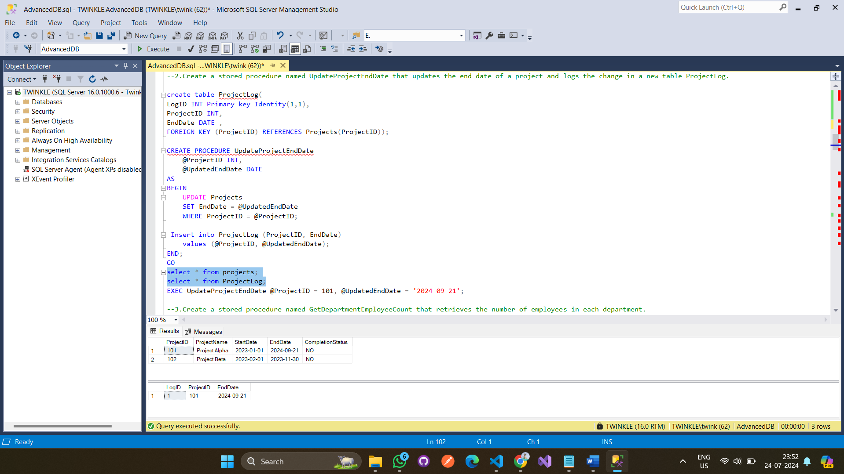

1. Create a stored procedure named GetDepartmentEmployeeCount that retrieves the number of employees in each department. A screenshot of a computer

   Description automatically generated
2. Create a stored procedure named InsertNewEmployee that inserts a new employee and their initial assignment within a transaction. A screenshot of a computer

   Description automatically generated

Output:

1. Create a stored procedure named GetEmployeesWithMultipleAssignments that retrieves employees who have more than one assignment.

1. Create a stored procedure named UpdateEmployeeDepartment that updates an employee's department and logs the change in a new table EmployeeLog.

1. Create a stored procedure named GetProjectsWithNoCurrentEmployees that retrieves projects with no current employees assigned.

1. Create a stored procedure named GetEmployeeAssignmentHistory that retrieves the assignment history of a specific employee.

1. Create a stored procedure named GetOverdueProjects that retrieves projects whose end date has passed but are not yet completed.

1. Create a stored procedure named GetEmployeesByRole that retrieves all employees assigned to a specific role.

1. Create a stored procedure named GetEmployeeCountByRole that retrieves the number of employees for each role.

1. Create a stored procedure named GetEmployeesWithNoCurrentAssignments that retrieves employees who do not have any current assignments.

1. Create a stored procedure named GetProjectAssignmentStatistics that retrieves statistics on the number of assignments per project.

